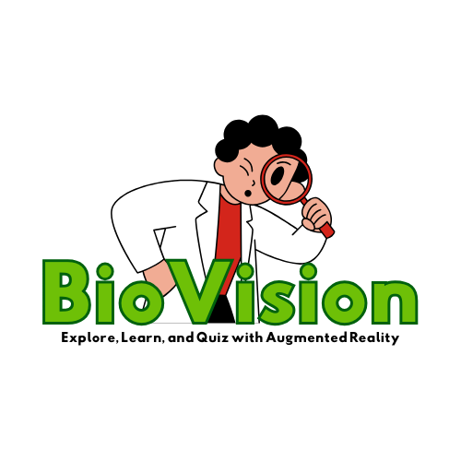

BIOLOGY I

The origin of this book is deeply rooted in my concern for the education, as well as the appreciation, of senior high school students in the field of biology. This book is designed, first and foremost, to enhance the understanding of the basic principles and concepts in the study of biology, and secondly to, write a biology book that is useful, interesting, and user-friendly.

Biology 1 is arranged in a traditional manner, progressing from the basic to the complex. It begins with a discussion of the cell theory, cell structure and function, differentiation of prokaryotic and eukaryotic cell, cell type’s tissues, and cell modifications. It then covers biological knowledge as an expanding spiral of knowledge. Thus, cell biology is followed by cell cycle, transport mechanisms, biological molecules, and energy transformation.

The book is divided into three major topics: 1. Cell, 2. Biological Molecules, and 3. Energy Transformation, The first major topic on cell begins with the discussion of cell theory where the basic properties of cells are described and explained, then it moves to cell structure and function, differentiation of prokaryotic and eukaryotic cells, and lastly types of cells and some structural modifications seen in both plant and animal cells. The second part of this topic talks about the cell cycle that describes and explains the different stages undergone by cells before and after division. The third part explains the different modes of cell transport, such as simple diffusion, facilitated transport, active transport, and bulk or vesicular transport.

The second major topic on biological molecules discusses about structure and function of molecules present in living things. These include large macromolecules such as proteins, carbohydrates, lipids, and nucleic acids, as well as small molecules such as primary metabolites, secondary metabolites, and natural products. Structural formula of each biological molecule is shown to understand not only their chemical composition, but also how they function.

The third major topic deals with the processes of changing one form of energy to another through photosynthesis and respiration, both aerobic and anaerobic types such as fermentation. In this lesson, the major features and chemical events in photosynthesis and respiration (both aerobic and anaerobic) are vividly explained through equations and diagrams that illustrate the step by step process involved in each type of energy transformation. Drawings of cell organelles where this energy transformation takes place are also provided for better comprehension.

Challenging exercises, in the form of worksheets and other activities, like simple experiments, are provided at the end of each unit to test the extent of understanding and level of appreciation of each student who will be taking up this course. Teachers who will be teaching this subject can formulate more questions to measure knowledge, understanding, application and extension of this discipline.

**Chapter I**

**Cell**

The cell is the basic unit of living matter. It is the smallest structure that is able to carry out all the basic properties of life. All organisms, including plants and animals, are composed of these tiny structure called cells. Cells vary in shape: ovoid, polygonal, Spiral, or may be shapeless like the amoeba. The environment appears to be an important factor that can influence the shape of the cell, while its form, its form, serves an adaptation to its performance.

Though cells greatly vary in size, they are generally quite small, ranging from one micron to thousandth of a millimetre to several microns. Only a few, such as the eggs of birds and some algae, can be visible to the unaided eye. The size of the cells is limited by what it might be termed the surface-volume dilemma. The cell as a system by itself need a surface area big enough to enable adequate nutrients to enter and for wastes to be eliminated. As cells size increases, the surface area becomes inadequate for exchange of these materials. This is why it becomes advantageous for cells to remain small.

The cell, which is composed of a variety of molecules working together, carries out basic functions of metabolism and homeostasis, and reproduces on its own or as part of a larger organism. Thus, cells are considered not only the fundamental structural unit, but also the functional unit of living organisms. The simplest organisms consist of but one cell like the protozoans. Organisms above this level of organization may be made up of thousands, millions, or even billions of cells. It has been estimated that the human body contains more than 50 thousand billion cells.

**1.1 Cell Theory**

In 1835 the French biologist Dujardin viewed some living cells with a microscope and found that they had content which was later named as protoplasm. Three years later after examining many and various forms of living things, the German botanist, Matthais Schleiden, proposed that all plants are composed of cells. The following year, Theodor Schwann, a German zoologist, made a similar statement regarding animal structure. Further work by the German physician Rudolph Virchow, showed that cells self-reproduce and "every cell comes from a pre-existing cell".

The collective work of these scientists helped create the cell theory that states that: a) all organisms are composed of one or more cells; b) cell is the structural unit of all organisms; c) cells come only from pre-existing cells because cells are self-reproducing; and d) cells contain hereditary material which is passed on to their offspring when they divide.

**1.2 Cell Structure and Function**

**Basic Cell Structure**

The cell is simply a mass of living protoplasm that has been compartmentalized to carry out specific functions. This mass has developed two distinct regions: the outermost liquid portion which is the cytoplasm; and the central, spherical, and denser portion which is the nucleus. The whole mass of protoplasm is surrounded by an extremely thin membrane called the plasma membrane or cytoplasmic membrane. The parts of the cell include the following:

**A. Plasma Membrane**

The cell is surrounded by a plasma membrane made up of a phospholipid bilayer with embedded proteins. It separates the cell's contents from its environment, and being a selectively - permeable membrane, allows only certain materials to cross it. Thus, one of the important functions of the plasma membrane is to control material exchanges between the cell and its environment. The lipids in the membrane are found to be made up mostly of phospholipids and cholesterol.

**Cytoplasm**

The cytoplasm that accounts for most of the cell's mass is an enormously complex mixture of water, sugar, ions, and proteins where most of the cell's metabolic functions take place. When viewed through the electron microscope, the cytoplasm is seen to contain many different organelles, each of which is made up of a specific set of proteins specialized for a particular function. The cytoplasm is also filled up with a network of fine membranes that constitutes the cytoskeleton and a fluid portion, the cytosol.

**C. Cytosol**

This is the fluid portion of the cytoplasm that generally represents about 55% of the total cell volume and is teeming with thousands of enzymes that catalyse the reactions of sugars, fatty acids, nucleotides, and amino acids. In addition, it contains a variety of different cytoskeletal proteins that gives shape to a cell, causes coordinated cytoplasmic movements, and provides a general framework used to help organize many enzymatic reactions.

**D. Nucleus**

The nucleus, located near the center of most cell, generally appears as an oval structure containing chromatin in a semifluid matrix called the nucleoplasm. The chromatin that looks grainy is actually a network of strands that condenses and coils into rod like structures during cell division. These are called chromosomes. All the cells of an individual, except for the egg and sperm, have a characteristic diploid number of chromosomes that is maintained constant through mitosis, a systematic process of nuclear division. The egg and the sperm, on the other hand, have only half the number of chromosomes characteristic of its species. This suggests that the chromosomes am the carriers of genetic information and that the nucleus, that contains them, is the command center of the cell.

**E. Nuclear Envelope**

The nuclear envelope that encloses the nucleus and separates it from the cytoplasm is a double-membrane structure perforated with thousands of tiny pores that span the entire length of the nuclear membrane. Nuclear pores permit the passage of ribosomal subunits and m-RNA out of the nucleus into the cytoplasm, and the passage of proteins from the cytoplasm into the nucleus. Thus, the nuclear pores act like gatekeepers that regulate what comes in and goes out of a nucleus.

**F. Ribosomes**

These are granular bodies in the cytoplasm where protein synthesis takes place. A functional ribosome is made up of large and small ribosomal submits each of which is composed of a mix of proteins and ribosomal RNA When ribosomes engaged in protein synthesis, they associate in clusters known as polyribosomes.

**Cell Organelles**

The cells of eukaryotes are highly compartmentalized structures with membranes that create internal spaces that divide the labor necessary to conduct specialized functions. Among the organelles present are as follows:

**A. Endomembrane System**

The endomembrane system is a series of interacting organelles such as the nuclear envelope, the membranes of the endoplasmic reticulum, the Golgi apparatus, and several types of vesicles. This system compartmentalizes the cell so that particular reactions can be carried out in specific regions and overall cell efficiency is increased. The organelles that constitute the endomembrane system are described below:

**1. Endoplasmic Reticulum**

This consists of an intricate system of membranous channels and tiny sacs physically continuous with the nuclear envelope. The endoplasmic reticulum consists of rough and smooth endoplasmic reticulum which have different structures and functions.

Rough endoplasmic reticulum is filled with ribosomes that give it the capacity to synthesize proteins from amino acids. It also contains enzymes that can catalyze chemical combination between carbohydrates and proteins forming glycoproteins which are important in many cell functions. Smooth endoplasmic reticulum, which is continuous with the nuclear envelope and the rough ER, has no ribosomes attached to its surface. It is in this organelle that lipids and hormones are produced. Both rough and smooth endoplasmic reticulum form vesicles that transport molecules to other parts of the cell, notably the Golgi apparatus.

**2. Golgi apparatus**

The Golgi apparatus is a series of flat, membrane-bound sacs whose appearance can be compared to a stack of pancakes. This organelle contains enzymes that modify, sort, and package proteins and lipids that have been delivered to it from the endoplasmic reticulum. They attach phosphate groups or sugars, and cut certain polypeptides. The finished products (membrane proteins, proteins for secretion, and enzymes) are sorted and packaged into new vesicles that carry them to the plasma membrane for export to other cells or to lysosomes to be broken down into their simpler forms for recycling. If these vesicles carrying various products are transported to other parts within the cell, the process is called endocytosis, if outside of the cell, the process is called exocytosis.

**3. Lysosomes**

These are membrane-bound vesicles that contain powerful hydrolytic enzymes specialized for intracellular digestion. These enzymes are called hydrolases because they characteristically operate best when adequate amount of water is present. The hydrolases, synthesized in the ER and processed through the Golgi apparatus, can break down wastes, ingested cells, and cellular debris delivered to it by other vesicles.

**B. Other Vesicles and Vacuoles**

**1. Peroxisomes**

Like the lysosomes, peroxisomes are membrane-bound vesicles that enclose enzymes. However, the enzymes in peroxisomes are synthesized by free ribosomes and transported into a peroxisome from the cytoplasm. These enzymes are involved in chemical reactions that result in the production of hydrogen peroxide. Hydrogen peroxide, a toxic molecule, is immediately broken down to water and oxygen by another peroxisomal enzyme called catalase. Application of hydrogen peroxide to a wound results in bubbling as enzyme catalase breaks it down.

**2. Vacuoles**

These organelles are similar to vesicles in being membranous sacs, but vacuoles are larger than vesicles. Some vacuoles can be very specialized like contractile vacuole that removes excess water from the cell and digestive vacuoles for breaking down nutrients. In general, few animal cells contain vacuoles; however, fat cells contain a very large lipid-engorged vacuole that takes up nearly two-thirds of the volume of the cell. Plants have vacuoles that contain not only water, sugars, and salts but also water-soluble pigments and toxic molecules. The pigments are responsible for many of the red, blue, or purple colors of flowers and some leaves. The toxic substances help protect plant from herbivorous animals.

**3. Plant Cell Central Vacuole**

The large central vacuole in plants may take up to 90% of the plant Cell's volume. It is filled with a watery fluid called sap that gives added physical support to the cell by maintaining hydrostatic pressure or turgor pressure within the cell. It also functions in storing both nutrients and waste products. When organelles age and become non-functional, they fuse with the vacuole, where digestive enzymes break them down. This is an analogous function to that carried out by lysosomes in animal cells.

**C. Energy-Related Organelles**

To maintain the structure and function of living things, a constant input of energy should be made available to them. Chloroplasts and mitochondria are the two membranous organelles that specialize in converting energy to a form that is usable by the cell.

**1. Chloroplast**

Cells of plants and many protists have organelles that enable them to synthesize organic foods from simple inorganic ones. These oval or disk-shaped organelles are called chloroplasts that specialize in photosynthesis. Each chloroplast has two outer membranes enclosing a semifluid interior, the stroma, that contains enzymes and the chloroplast's own DNA A third highly folded membrane, where photosynthesis occurs, forms a single continuous compartment inside the stroma. In many ways, chloroplasts resemble photosynthetic bacteria, and they are thought to have evolved from them.

**2. Mitochondrion**

The mitochondrion is known as the powerhouse of the cell where energy in the form of ATP is produced. It has two membranes, the outer membrane and the inner membrane. The inner membrane is highly convoluted into folds called cristae that extends into the semifluid matrix. This matrix enclosed by the inner membrane contains a concentrated mixture of enzymes that breaks down carbohydrates and other organic molecules producing ATP. Just like the chloroplast, this organelle is very similar to a bacterium in size, form and biochemistry. It also has its own DNA and ribosomes, and divides independently of the cell. These characteristics are suggestive that mitochondria might have evolved from aerobic bacteria that took up permanent residence inside a host cell.

**D. The Cytoskeleton**

The cytoskeleton is a system of interconnected protein filaments. It contains actin filaments, intermediate filaments, and microtubules, which maintain cell shape and allow cells and its organelles to move.

**1.3 Prokaryotic vs Eukaryotic Cells**

Living things, based on the presence of a nucleus in their cells, are classified into two large groups: prokaryotes and eukaryotes. Organisms whose cells have no definite nucleus because of the absence of a nuclear membrane are called prokaryotes. Organisms whose cells have a nucleus surrounded by a nuclear- membrane are called eukaryotes. Bacteria and their relatives are prokaryotes, while all other organisms, including plants and animals, are eukaryotes.

**1. Prokaryotic Cell**

As a group, prokaryotes are one of the most abundant and diverse life forms on Earth. They are present in great numbers in the air, and soil, as well as living in and on other organisms. Even though prokaryotes are structurally less, complicated than eukaryotes (Fig. 1), their metabolic capabilities far exceed those of eukaryotes. Prokaryotes have been an extremely successful group of organisms whose evolutionary history dates back to the first cells on Earth.

All bacteria and archaea ate single-celled and have no nucleus. Physically, they look so similar that archaea were once thought to be an unusual group of bacteria. Both were classified as prokaryotes, a term that means "before the nucleus." By 1977, it had been clear that archaea are more closely related to eukaryotes than to bacteria, so they were grouped under separate domains.

Most bacteria and archaea are quite small, no bigger than a few micrometers. Both do have a complex internal framework, but protein filaments are found under the plasma membrane to reinforce the cell's shape. Such filaments also act as support for internal structures. There are three basic shapes common to prokaryotes: a) bacillus, rod-shaped, b) coccus, spherical, c) spirilla, long rods twisted into rigid spirals, and spirochete, if flexible.

**Structure of Prokaryotes**

**a. Cell Envelope**

In bacteria, the cell envelop is made up of the plasma membrane, the cell wall, and the glycocalyx. The plasma membrane consists of phospholipid bilayer with embedded proteins. Its function LS to regulate entrance and exit of substances into and out of the cytoplasm to maintain its normal composition. The plasma membrane can form internal pouches called mesosomes which most likely increase the internal surface area for the attachment of enzymes carrying on metabolic activities.

The cell wall when present, maintains the shape of the cell, even if the cytoplasm should happen to take up an abundance of water. In plant cell, the cell wall is strengthened by cellulose, while in bacteria, by peptidoglycan which is a complex molecule containing a unique amino disaccharide and peptide fragments.

The glycocalyxis a layer of polysaccharides located outside the cell wall in some bacteria. When the layer is well organized and not easily washed off, it is called a capsule; if not well organized and easily removed, it is called a slime layer. The glycocalyx protects the bacteria from drying out and helps them resist a host's immune system. It also facilitates attachment of bacteria to almost any surface.

**b. Cytoplasm**

The cytoplasm is a semifluid solution composed of water and inorganic and organic molecules encased by a plasma membrane. Found among the organic molecules are a variety of enzymes which speed up the many types of chemical reactions involved in metabolism.

The DNA in a prokaryote is found in a single, coiled chromosome that is located in a region called the nucleoid. Many bacteria also have extrachromosomal pieces of circular DNA called plasmids. Plasmids are routinely used in biotechnology laboratories as a molecular vehicle, also called a vector, to transport DNA from different organisms, including humans, into a bacterium and thereby combine their genes in the process. This technique is done to produce new medicines and many commercial products that we use every day.

The many proteins encoded by the bacterial DNA are synthesized on tiny structures called ribosomes. A bacterial cell contains thousands of ribosomes scattered in its cytoplasm. They are similar in shape and function, but are smaller than eukaryotic ribosomes. Like their eukaryotic counterparts, bacterial ribosomes still contain RNA and protein in two sub-units.

**c. Appendages**

The appendages of a bacterium, namely flagella, fimbriae, and conjugation pili, are made up of protein. The flagella, consisting of a filament, a hook, and a basal body, help to propel the bacteria in water. The number and location of flagella can be used to help distinguish the different types of bacteria.

Another type of appendage is the fimbriae. The fimbriae are small, bristle like fibers that grow from the cell surface. They are not used for locomotion; instead, they help in attaching bacteria to surface. Conjugation pili are rigid tubular structures used by bacteria to pass DNA from cell to cell. Bacteria reproduce asexually by binary fission, but they can exchange DNA with other bacteria through the conjugation pili. They can also take up DNA from the external medium or by way of viruses.

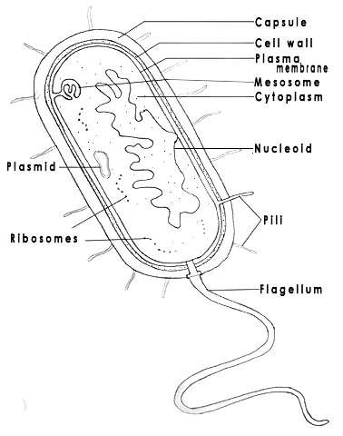Figure 1

STRUCTURE OF A PROKARYOTIC CELL

**2. Eukaryotic Cell**

Eukaryotic cells, like prokaryotic cells and archaeans, have a plasma membrane that separates the contents of the cell from the environment and regulates the passage of molecules into and out of the cytoplasm. The plasma membrane is a phospholipid bilayer with embedded proteins. Unlike prokaryotes, eukaryotes have a definite nucleus. Some scientists have suggested that the nucleus evolved as the result of the invagination, or pocketing, of the plasma membrane.

Much scientific evidence also shows that mitochondria and chloroplasts the two energy-related organelles present in all eukaryotic cells, arose when large eukaryotic cell engulfed independent prokaryotes. This relationship is referred to as the endosymbiotic theory. This theory explains why mitochondria and chloroplasts are bounded by a double membrane and contain their own genetic material separate from that of the nucleus.

**Structure of Eukaryotic Cell**

Eukaryotes are highly-compartmentalized types of cells (Fig 2). Membranes create internal spaces that divide the cytoplasm into small compartments called organelles. These organelles have structures specialized to carry out specific functions. Nearly all organelles are surrounded by a membrane embedded with proteins, many of which are enzymes. These enzymes make products specific for a certain organelle, but their integrated actions benefit the entire cell. The cell can be seen as a system of interconnected organelles that work together to metabolize, regulate, and conduct other equally important life processes. Among the organelles present in a eukaryotic cell are: endoplasmic reticulum, golgi apparatus, lysosomes, mitochondria, chloroplasts, peroxisomes, cytoskeleton, centrioles and cilia and flagella. The structure and function of each of these organelles are given in the previous pages.

Figure 2

EUKARYOTIC CELL

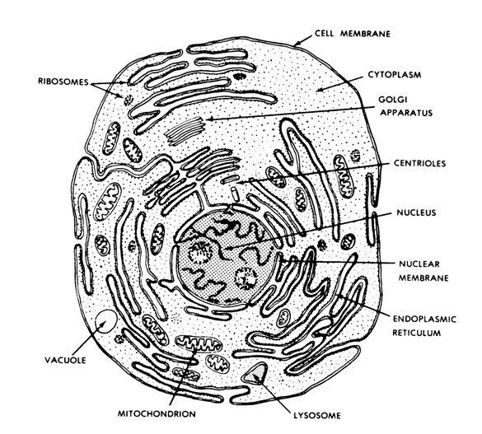**1.4 Cell Types**

Multi-celled living things such as plants and animals are very complex and highly organized. They start life as a single cell, the fertilized egg or zygote produced from the union of egg and sperm cells. The zygote undergoes a series of cell divisions, producing many cells that will eventually form the variety of tissues that make up organs and organ systems. Although all of these cells carry out a number of common functions - such as obtaining nutrients, metabolizing them to produce energy and synthesize basic cellular constituents, and then later on reproducing themselves - the cells of multicellular organisms further differentiate so that they can become specialized for additional and unique functions.

1. 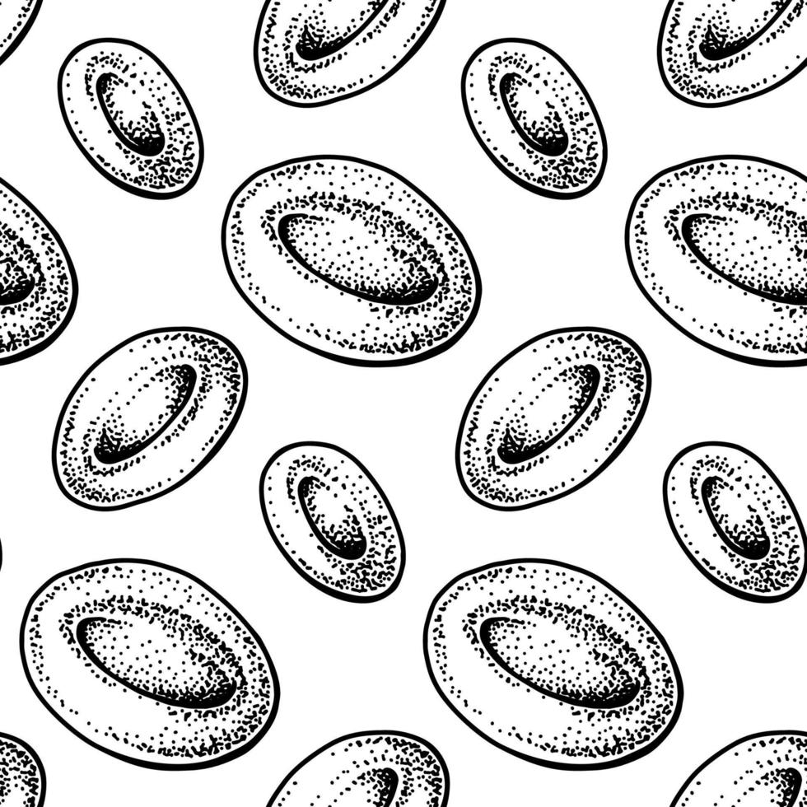**Red blood cells** are small biconcave disk-shaped cells without nuclei (Fig. 14). They contain a red pigment called hemoglobin which is made up of protein globin and a complex iron-containing **heme**. The iron component forms a loose connection with oxygen, and in this way red blood cells transport oxygen and readily give it up in the tissues.

Figure 14

RED BLOOD CELLS

1. **White blood cells** are much larger than red blood cells and contain nuclei which when stained typically looks blue or purple (Fig. 15). White blood cells fight infection primarily in two ways: a) engulfing infectious pathogens (phagocytosis), and b) producing antibodies that combine with foreign substances, either to inactivate them, or kill them outright.

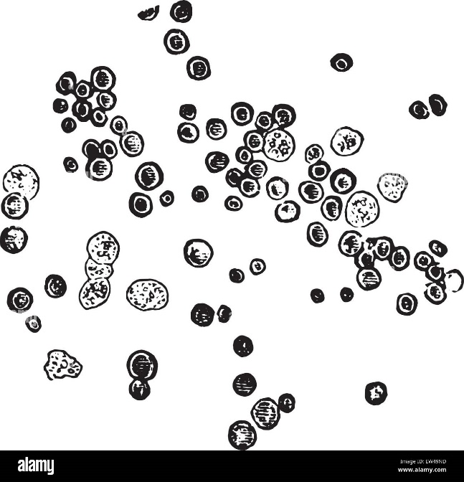

Figure 15

WHITE BLOOD CELLS

**1.5 Cell Modifications**

Features or structures of the cell that make them different from another type of cell and at the same time enable them to carry out unusual functions are called cell modifications. This commonly occurs in multicellular eukaryotes, where the opportunity for cell specialization arises. Cell modifications seen in plants and animals are discussed below.

**A. Plant Cell Modifications**

1. Succulent leaves of century plant (Agave), aloes, sedums, and desert plants, which are thick and fleshy, store water to enable them to survive long periods of drought and semi desert conditions.
2. Tendrils (modified leaf petioles, veins, or stipules), growing in climbing plants like garden peas, bitter gourd and cucumber, can coil around supports for anchorage.
3. Younger leaves of poinsettia are brightly colored to help in attracting pollinators.
4. Tubular or vase-shaped leaves of Pitcher plants secrete a fluid for digesting insects falling into their cavities.
5. Lateral roots of mangrove trees growing in swamps produce pneumatophores (upright conical growths) that aerate the submerged roots.
6. Adventitious roots (called brace or prop roots) that develop from the stem or even from the leaves, such as in pandan or corn, grow into the ground to help underground roots support the stem.

**B. Animal Cell Modifications**

Microvilli are finger-like projections extending from the free surface of epithelial cells that increase the surface area across which substances are absorbed.

1. Fimbriae are finger-like extensions from the oviduct near the ovary that help to propel the released ova towards the fallopian tube.
2. Alveoli are microscopic, grapelike air sacs found at the tip of the bronchioles in the lungs that provide tremendous surface area for gas exchange during respiration.
3. Goblet cell is a glandular, modified simple columnar epithelial cell that secretes gel-forming mucins, the major component of mucus.
4. Red blood cell is a biconcave disk-shaped cell that provides more surface area for gas exchange; absence of its nucleus in mature red blood cells gives more space for the hemoglobin.
5. White blood cell, also called leukocyte, contains enzymes and other proteins needed to protect the body against both infectious disease and foreign invaders.
6. Neuron is a specialized cell with three parts: dendrites, cell body, and axon, which facilitates transmission of nerve impulses to and from the brain and the spinal cord.
7. Sperm cell has lots of mitochondria that will produce the energy needed to propel its flagellum towards the egg cell during fertilization; and contains the enzyme needed to penetrate the thick membrane surrounding the egg and deliver its genetic material.
8. Ciliated epithelium located in the upper airways sweeps mucus with inhaled particles away from the lungs. Cilia in the oviduct move an egg toward the uterus.

**1.6 Cell Cycle**

Cell cycle is an orderly sequence of stages that takes place from the time a eukaryotic cell divides to the time the resulting daughter cells also divide. The two phases of the cell cycle are the interphase that includes a number of stages, and the mitotic stage when mitosis and cytokinesis occur (Fig. 30).

When a cell is about to divide, it grows larger, the number of organelles doubles, and the amount of DNA also doubles as replication of DNA takes place. All of these happen during interphase, where a typical cell spends most of its life. Interphase, which is typically the longest stage, consists of three stages:

l. GI, the first interval (or gap) of cell growth, before DNA replication

2. S, the time of synthesis (DNA replication)

3. G2, the second interval (or gap), when the cell prepares to divide.

G1 and G2 were named gap intervals because cells at these stages outwardly seem to be inactive, but they are not. Most cells in the GI stage are busy undergoing metabolic activities. After G1, cells enter S, where DNA is replicated. During G2, important organelles and other materials which will play important role during cell division, are synthesized by the cell. An example of this organelle is a centriole which is replicated before the cell divides. Once S begins, DNA replication usually proceeds at a predictable rate and ends before mitosis begins.

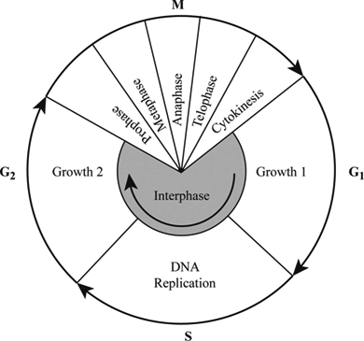

Figure 30

CELL CYCLE

Controls Over the Cell Cycle

Activities of a cell, like the cell cycle, are influenced by certain gene controls that produce signaling proteins received at the plasma membrane. Researchers have identified a family of internal signaling proteins called cyclins that increase or decrease as the cell cycle continues. There are three main checkpoints during the cell cycle: a) GI checkpoint, b) G2checkpoint, and c) Mitosis (M) checkpoint (Fig. 31).

In mammalian cells, the signaling protein p53 stops the cycle at the G1 checkpoint when DNA is damaged. In the name p53, p means protein, and 53 pertains to its molecular weight in kilodaltons. If DNA is damaged, p53 initiates DNA repair, but increasing levels of p53 can lead to apoptosis, which is programmed cell death. A cell dies, or undergoes apoptosis if DNA is not repaired.

The cell cycle may also stop at the G2 checkpoint DNA has not been replicated properly. This checkpoint prevents the initiation of the M stage before completion of the S stage. If DNA is physically damaged, such as from exposure to solar radiation or X-rays, or cannot be repaired, the cell undergoes apoptosis.

Another cycle checkpoint occurs during the mitotic (M) stage. The cycle stops if the chromosomes are not properly attached to the mitotic spindle. Normally the mitotic spindle makes sure that the chromosomes are distributed accurately to the daughter cells.

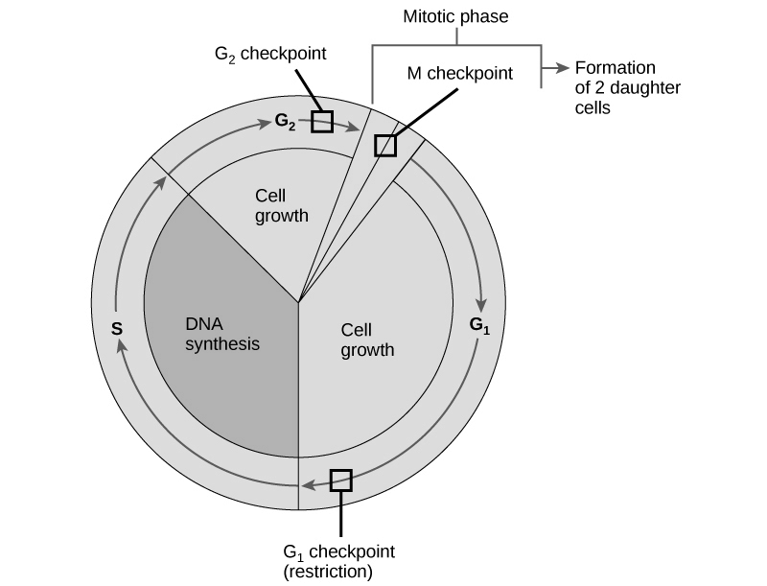

Figure 31

CELL CYCLE CONTROL

**The Process of Mitosis**

Mitosis is an orderly sequence of events involving changes both in the nucleus and in the cytoplasm (Fig. 32). Although mitosis is a continuous process with no stopping or starting between phases, for the sake of better understanding, this process can be subdivided into the following stages: early prophase, prophase, prometaphase, metaphase, anaphase, and telophase.

**Stages:**

**1. Early Prophase**

This is the beginning of mitosis. In the nucleus, the chromatin is condensing into visible chromosomes and centrosome is being duplicate.

**2. Prophase**

Nucleolus has disappeared. The chromosomes become more distinct as they condense further. One of the two centrosomes moves to the opposite side of the cell. The nuclear membrane breaks up and the spindle is In the process of forming.

**3. Prometaphase/Late Prophase**

The nuclear membrane is gone, and the chromosomes have become very distinct. Microtubules of the bipolar spindle assemble and attach sister chromatids to opposite spindle poles.

**4. Metaphase**

All of the chromosomes are aligned at the center (metaphase plate) between the spindle poles. Microtubules attach each chromatid to one of the spindle poles and its sister chromatid to the opposite pole.

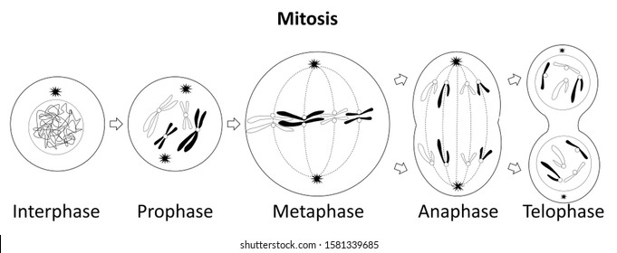**5. Anaphase**

Sister chromatids separate and become daughter chromosomes that move toward the spindle poles. Thus, each pole receives the same number and, types of chromosomes as the parent cell.

**6. Telophase**

The chromosomes reach the spindle poles and start to decondense to become indistinct chromatin. Daughter cells are forming as nuclear membrane and nucleoli reappear. New plasma membrane may assemble between them.

**Cytokinesis**

A cell's cytoplasm usually divides after mitosis. The process of cytoplasmic division, or cytokinesis differs among eukaryotes.

In animal cell, the plasma membrane sinks inward to form a thin indentation between the forming spindle poles called the cleavage furrow. This is brought about by the contraction of a band of protein filaments consisting of actin and myosin filaments found under the plasma membrane. This band of filaments is called the contractile ring. As this ting contracts and shrinks, the plasma membrane is dragged inward until the cytoplasm (and the cell) is pinched into two.

In plant cell, the contractile ring mechanism that works for animal cells would not work for a plant cell as the contractile force of microfilaments is not strong enough to pinch through plant cell walls which are stiff with cellulose and often lignin.

Cytoplasmic division in plant cell is achieved through the formation of a structure called the cell plate. This cell plate is formed as vesicles derived from the Golgi apparatus and the cell's surface move to the division plane and fuse into a disk-shaped cell plate. The plate grows outward until its edges become attached to the plasma membrane and thus form a partition in the middle of the cytoplasm. In time, this plate develops into a primary wall that merges with the parent's cell wall. At the end of division, each daughter cell becomes enclosed by its own plasma membrane and its own cell wall.

Figure 32

MITOSIS

The Process of Meiosis

Meiosis is a nuclear division mechanism that occurs in reproductive cells, the egg cells and the sperm cells. It is a type of nuclear division that reduces the number of chromosomes from the diploid number (2n) to the haploid number (n) and gives rise to new combination of parental alleles. Meiosis occurs in two stages that equally distribute chromosomes into two new nuclei two times (Fig. 33). Below are the stages of meiosis that starts with interphase and followed by two successive cell divisions.

|  |  |  |
| --- | --- | --- |
| Interphase | Meiosis I | Meiosis II |
| DNA is replicated | Prophase I | Prophase II |
| Prior to meiosis 1 | Metaphase I | Metaphase II |
|  | Anaphase I | Anaphase II |
|  | Telophase I | Telophase II |

The nucleus of a diploid (2n) cell contains two sets of chromosomes, one from each parent cell. DNA replication takes place before meiosis 1 begins, so each one of the chromosomes consists of two sister chromatids.

**Stages of Meiosis I**

**1. Prophase I**

During this stage the homologous chromosomes condense, pair up and exchange segments. Spindle microtubules become attached to them as the nuclear membrane breaks up.

**2. Metaphase I**

At metaphase I. homologous chromosome pairs are aligned in the middle of the cell. The two chromosomes of each pair become joined to the spindle microtubules at the opposite sides of the cell.

**3. Anaphase I**

In anaphase I r all of the homologous chromosomes separate and begin moving toward the spindle poles.

**4. Telophase I**

During telophase I, a new nuclear membrane forms around each cluster of chromosomes as the DNA loosens up. The two nuclei have a single set of chromosomes, so they are haploid (n).

**Stages of Meiosis II**

**1. Prophase II**

The chromosomes condense and the spindle microtubules become attached to each sister chromatid as the nuclear membrane breaks up.

**2. Metaphase II**

The chromosomes which are still duplicated, or with two molecules of DNA, are aligned in the middle of the cell.

**3. Anaphase II**

In anaphase II, the sister chromatids of each chromosome are pulled apart and move toward the opposite sides of the cell. Each chromosome is now made up of one molecule of DNA.

**4. Telophase II**

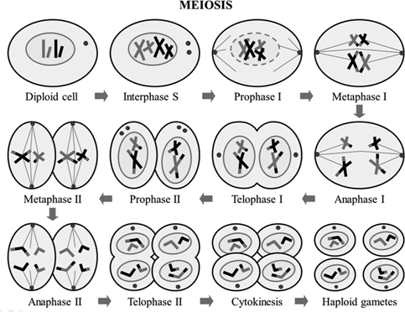During telophase II, new nuclear membrane forms around each cluster of chromosomes as the DNA loosens. The cytoplasm often divides at this point to form four haploid (n) cells whose nuclei contain one set of (unduplicated) chromosomes.

Figure 33

MEIOSIS

**1.7 Transport Mechanisms**

**Simple Diffusion**

Diffusion is the spontaneous movement of molecules from a higher concentration to a lower concentration, that is, down their concentration gradient, until molecules are distributed equally (Fig.35). This is a process that results from the random motion of molecules. For instance, when a crystal of dye is dropped in water, the molecules of both dye and water move in different directions, but their net movement, that is the sum of their motion, is toward the region with lower concentration.

A solution is made up of both a solute, usually a solid, and a solvent, usually a liquid. In this case, the solute is the dye, and the solvent is the water. Once the solute and the solvent are evenly distributed, their movement continues, but there is no net movement in either direction.

The speed of mixing between molecules depends on the following factors:

**a. Size**

It takes more energy to move bigger molecules, thus, the smaller the size, the faster the rate of diffusion, and vice versa.

**b. Temperature**

Molecules move faster at higher temperature, making them collide more often. Thus, the higher the temperature, the faster the rate of diffusion.

**c. Concentration**

Concentration gradient is the difference in solute concentration between adjacent regions of a solution. Solutes tend to diffuse "down" their concentration gradient, that is, from a region of higher concentration to one of lower concentration. As the concentration of a solution increases, the molecules become more crowded, and the collision between them become more often. Thus, during a given interval of time, more molecules are bumped out of a region of higher concentration than bumped into it.

**d. Charge**

Charged particles of matter (ion or molecule) in a fluid add up to the fluids overall electrical charge. A difference in charge between two regions of the fluid can influence the rate and direction of diffusion between them. For example, positively-charge substances like sodium ions will tend to diffuse toward a region with an overall negative charge.

**e. Pressure**

A change, or difference in pressure between two adjoining regions may affect the rate and direction of diffusion. Pressure squeezes molecules together, and the more crowded the molecules become, the more frequent molecules collide and rebound among them, thus, the faster the diffusion.

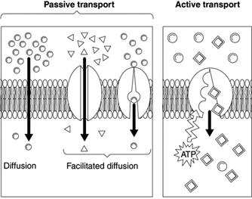

Figure 35

SIMPLE DIFFUSION AND FACILITATED DIFFUSION

**Facilitated Transport (Passive Transport)**

In passive transport, a transport protein moves substances from a region of higher concentration to one of lower concentration (Fig. 35). This is the reason why passive transport is also called facilitated transport. In facilitated transport, the solute simply binds to the transport protein and gets released to the other side of the membrane.

Passive transport protein moves substances down their concentration gradient by: a) changing its shape when it binds to the molecule, like glucose, and then reverting to its original shape after releasing the molecule to the other side of the membrane; b) forming permanently open channels through a membrane; and c) forming gated channels that open and close in response to a stimulus such as binding to a signaling molecule or a shift in electrical charge.

**Active Transport**

In active transport, substances are moved against their concentration gradient, i.e., from lower concentration to one of higher concentration (Fig. 36). To make this possible, transport protein uses energy from ATP to pump a solute against its concentration gradient. An example of this is the calcium pump that moves calcium ions across the cell membrane. This process is important to maintain the concentration of a particular solute at a certain level. Calcium ions act as potent messenger inside cells and they affect the activity of many enzymes.



Figure 36

ACTIVE TRANSPORT

**Bulk/Vesicular Transport**

This mode of transport involves movement of large particles, or even a virus through a vesicle that is formed when a patch of membrane bulges into the cytoplasm because the hydrophobic tails of the lipids in the bilayerare repelled by water on both sides (Fig. 37).

There are two modes of transit:

**1. Exocytosis**

It involves the transport of substances in bulk outside of the cell. A vesicle formed from the endoplasmic reticulum moves to the cell surface, its lipid bilayer membrane studded with proteins fuses with the plasma membrane, and then releases its contents to the surroundings.

**2. Endocytosis**

It involves the transport of substances in bulk into the interior of the cell. As the cell takes up substances in bulk near its outer surface, a small patch of plasma membrane balloons inward taking extracellular fluid with it. The balloon moves farther into the cytoplasm and then pinches off as a vesicle. The vesicle delivers its contents to an organelle or stores them in a 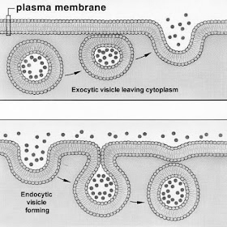cytoplasmic region.

Figure 37

TYPES OF VESICULAR TRANSPORT

**Energy Transformation**

Life depends on a continuous supply of energy needed to sustain its different activities. This energy is stored in the chemical bonds of organic compounds. Energy from this organic compound is released when certain chemical bonds are broken.

Examples of compounds that store energy include ATP, NADH. NADPH, and FADH2. Among these compounds, ATP is considered as the energy-currency of the cell since it is used to power most if not all, of its chemical activities. Adenosine triphosphate, or ATP, consists of three parts: ribose (a 5-carbon sugar), adenine, and triphosphate o group. An ATP molecule releases chemical energy whenever a bond holding the end phosphate from ATP is broken. This chemical reaction produces a new molecule of ADY which can combine again with a third phosphate group to form another ATP molecule. The chemical energy released by the breaking of a phosphate bond in ATP can be used by the cell to do three main types of biological work; a) mechanical function of the cell (movement of cilia an age a ; active transport of ions and molecules across cell membranes; and c) synthesis and breakdown of large molecules.

Because cells are constantly undergoing chemical reactions to sustain its various activities, they need a constant supply of ATP. Cells generate a continuous supply of ATP by attaching a third phosphate to an ADP molecule. This cycle of making and breaking down ATP that occurs 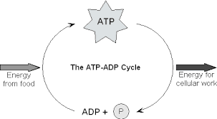continuously in a cell is summarized on the succeeding page:

**Steps:**

**1. Stored energy**

Energy released from the oxidation of glucose is then stored in the chemical bonds that join the phosphate groups in ATR

**2. Releasing Energy**

When the chemical bonds between phosphate groups in ATP are broken, its stored energy is released and made available for the different cell activities. This chemical reaction produces ADP

**3. Energy Depleted**

ADP has one less phosphate group than ATP and therefore contains less chemical energy.

**4. Making ATP**

Energy released by other chemical reactions, like glucose oxidation, can be used to bond a phosphate group to ADP, making ATP.

**Coupled Reactions**

The energy released from ATP as the chemical bond joining its third phosphate group is broken, is coupled to an energy-requiring reaction. This coupling reaction is represented with a diagram shown below:

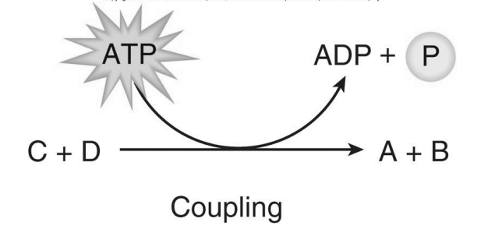

There are two ways by which the cell couples ATP hydrolysis to an energy requiring reaction: a) energizing a reactant, and b) changing the shape of a reactant. Both of these can be done by transferring a phosphate group to the reactant so that the product is phosphorylated. This is shown during protein synthesis where an enzyme transfers a phosphate group from ATP to each amino acid in turn. This phosphate-transfer supplies the energy needed to overcome the energy cost associated with bonding one amino acid to another.

**Photosynthesis**

For life on earth to continue, there must be a continuous supply of energy to power all chemical reactions needed to provide materials as well as energy for the cell. Although sunlight is the ultimate source of energy, not all forms of life can use it to directly power protein synthesis or other energy-requiring reactions that all organisms must run in order to stay alive. The energy of the sun can be converted into the energy present in chemical bonds through the process of photosynthesis. Unlike sunlight, chemical energy can power the reactions of life, and it can be stored for use at a later time.

Photosynthesis occurs in cells containing chloroplasts found in plants and many protists. (Fig. 3.1). Chloroplasts are organelles with structures specially designed to carry out photosynthesis. They have two outer membranes enclosing a stroma (semi - fluid interior) where the chloroplasts own DNA, some ribosomes, and an inner, much folded thylakoid membrane are suspended. The folds of a thylakoid membrane typically form stacks of interconnected disks called grana. The space enclosed by a thylakoid membrane is connected to the space of every other thylakoid within a chloroplast, thus forming a single, continuous compartment.

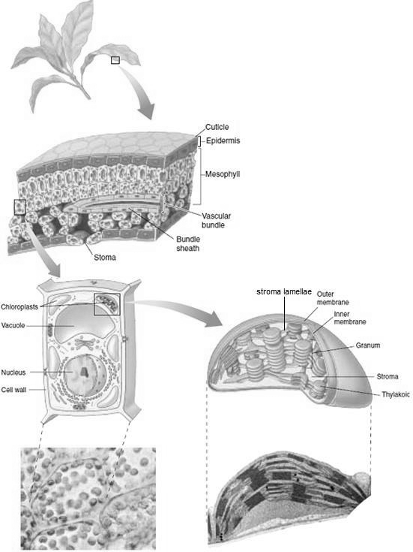

Figure 43

STRUCTURE OF LEAF AND ITS CHLOROPLAST

Humans and other animals obtain energy and carbon by breaking down organic molecules that have been produced by other organisms. Plants and other photosynthetic producers, by contrast, get energy directly from the environment, and carbon atoms from inorganic molecules like CQ. Organisms like plants that can synthesize organic compounds like glucose directly from inorganic compounds are referred to as autotrophs, while those who cannot make their own organic food but obtain them from others are referred to as heterotrophs.

Green plants and other photosynthetic organisms use pigments to capture visible light. A pigment is an organic molecule that selectively absorbs light of certain wavelengths and then reflects the rest of the visible light spectrum. Wavelengths of light that are not absorbed but are reflected, give each pigment its characteristic color. For example, a pigment that absorbs violet, blue, and green light, and reflects the rest such as yellow, orange, and red light, will appear orange to us.

Photosynthetic organisms differ in the type of chlorophyll they contain. In plants, chlorophyll a and b play vital roles in photosynthesis. Chlorophyll a and b absorb violet, blue, and red light, and reflect green light, thus plants appear green to us. Other accessory pigments, like carotenoids, are used by plants too during photosynthesis. Carotenoids, with shades of yellow and orange, absorb light in the violet-blue-green range, thus absorbing additional wavelengths of light for photosynthesis. These accessory pigments have antioxidant properties that help protect plants and other organisms from the damaging effects of the sun's ultraviolet rays. Other pigments like anthocyanin (red and blue), present in flowers like roses and violets, have appealing colors that attract animals to ripening fruit and pollinators to flowers.

Photosynthesis is a metabolic pathway in which the radiant energy of the sun is used to build organic molecules like glucose from carbon dioxide and water. Shown below is a chemical equation that represents the chemical reaction taking place during photosynthesis:

Photosynthesis, however, is not a single reaction, but is a metabolic pathway involving a series of many chemical reactions. The reactions occur in two stages: light- dependent reaction and the light-independent reactions.

**Light-Dependent Reaction**

The light-dependent reactions are so named because they only take place during day time when solar energy is available. The green pigment chlorophyll, present in thylakoid membranes, is largely responsible for the absorption of solar energy that drives photosynthesis.

During the light reactions, the sun's energy energizes electrons that become transported along an electron transport chain. As the electrons move down the chain, energy is released and used to produce ATP molecules. Energized electrons, together with hydrogen ions, are also taken up by NADP which is reduced and becomes NADPH. The equation below can be used to summarize the light reactions because they involve conversion of light energy into chemical energy.

solar energy chemical energy

(ATP, NADPH)

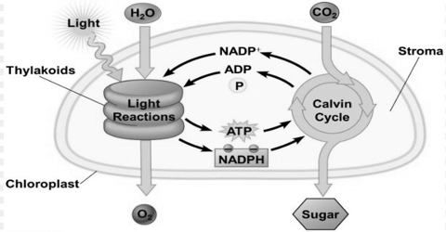**Light-independent Reactions (Calvin Cycle Reactions)**

The light-independent reactions, otherwise known as Calvin cycle reactions, were named after Melvin Calvin who received a Nobel Prize for discovering the enzymatic reactions that reduce carbon dioxide to a carbohydrate during the dark (light-independent) reaction of photosynthesis. The enzymes that make this chemical reaction happen during both day and night are located in the stroma, the semifluid interior of the chloroplast.

During the Calvin cycle reactions, C02 is taken up and then reduced to a carbohydrate which can be reorganized into glucose. The equation below represents the chemical reactions during Calvin cycle where ATP and NADPH produced during the light reactions are used to reduce carbon dioxide.

chemical energy chemical energy

(ATP, NADPH) (carbohydrate)

Figure 44 on the next page summarizes what happens during both the light- dependent and Calvin cycle reactions:

Figure 44

OVERVIEW OF PHOTOSYNTHESIS

The process of photosynthesis consists of the light reactions and the Calvin cycle reactions. The light reactions, which take place in the thylakoid membrane, produce ATP and NADPH. During the Calvin cycle, which occurs in the stroma of the chloroplast, ATP and NADPH are used to reduce carbon dioxide to a carbohydrate.

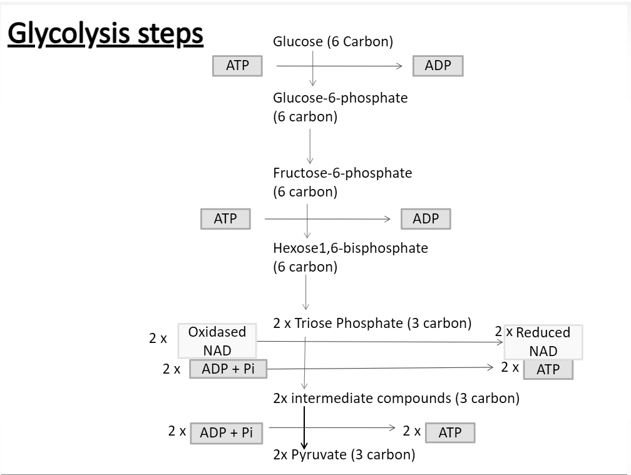**Aerobic respiration can be divided into three stages:**

**1. Glycolysis**

Respiration, which can be either aerobic or anaerobic, begins with glycolysis. Glycolysis, which occurs in the cytoplasm, is a process that involves the conversion of glucose into pyruvate and release of its stored energy. The pyruvate produced in this process is a three-carbon molecule that enters the Krebs cycle.

The step by step process of glycolysis is shown in Fig. 46. For every glucose molecule that undergoes glycolysis, a net yield of two reduced NAD (NADH), two ATP, and two pyruvate molecules are produced. NADH, like ATP, is an energy-storing compound. Only about 2 percent of the chemical energy stored in glucose molecule is released during glycolysis. Most of the remaining chemical energy is contained in the resulting pyruvate molecules, and released in the next stage, the Krebs cycle.

Figure 47

GLYCOLYSIS

2. Krebs Cycle

The two pyruvate molecules produced during glycolysis are converted into acetyl-CoA which enters the Krebs Cycle. During this stage. acetyl- CoA is broken down into COY ATP. NADH, and FADH. The Krebs Cycle obtained its name after its discoverer Hans Krebs. This cycle can also be called citric acid cycle because the first product formed is citric acid.

Krebs cycle produces one ATP from each pyruvate molecule. Since two pyruvate molecules are formed from every glucose molecule that has undergone glycolysis, two molecules of ATP therefore be produced during Krebs cycle. The energy stored in NADH and FADH2 will be used to synthesize more ATP. The steps in Krebs cycle are illustrated below (Fig. 48):

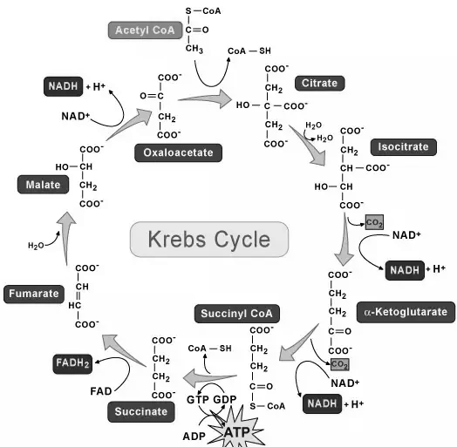

Figure 48

KREBS CYCLE